**Home Page:**The home page will consist of two options (sign in or sign up) and possibly a short overview of the application and its use. Once the user logs in, “My Page” will serve as the new home page.  
*For the actual website, the “MY PAGE” and “CS326” tabs will not be there.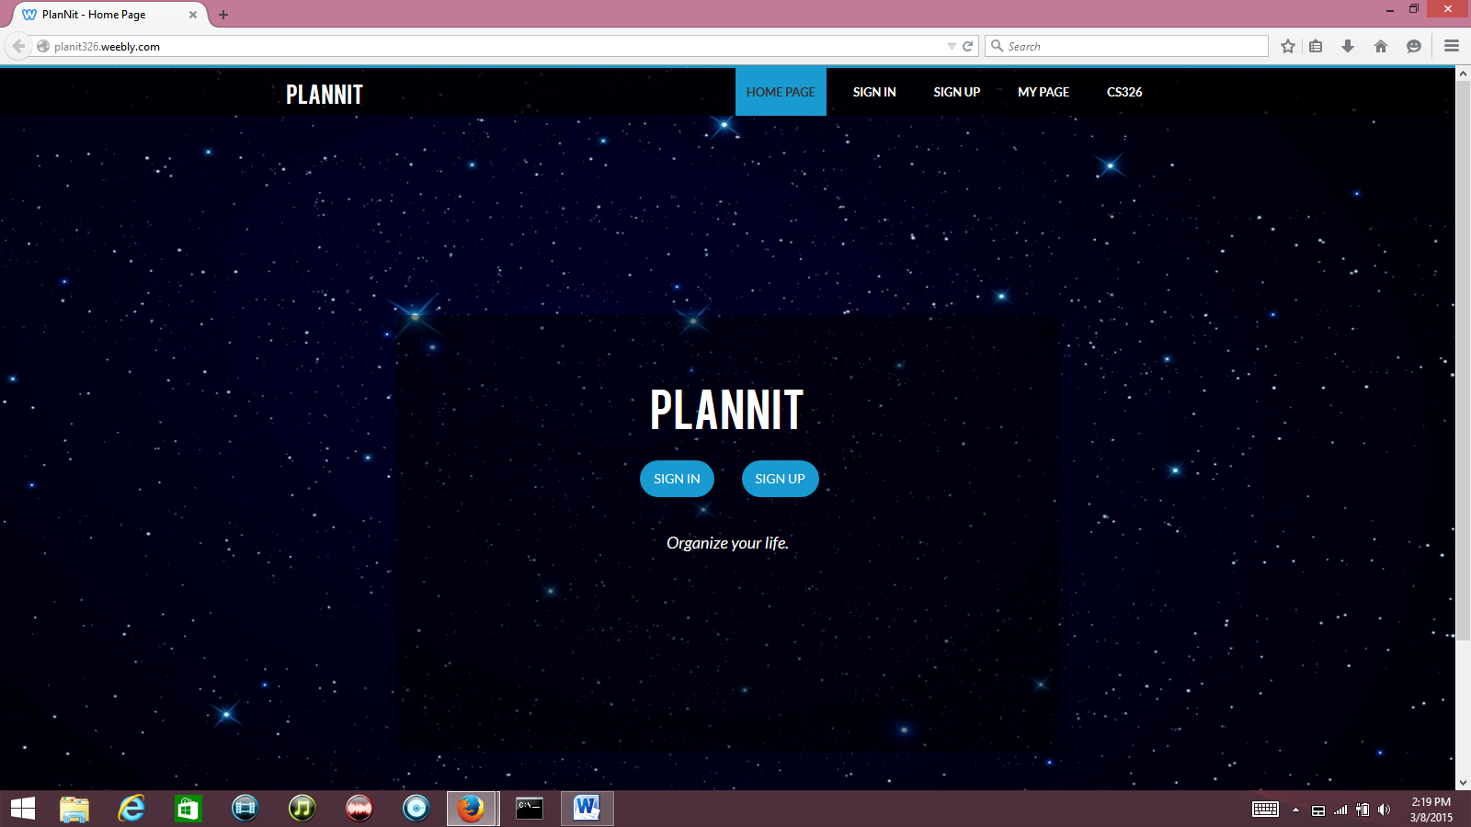

**Login Page:**The login page will be very simple: it will ask the user for their username and password. There will also be a “forgot password” option (will be added), that will prompt the user to enter their email. From there, it will ask the user to change their password through the user’s email account.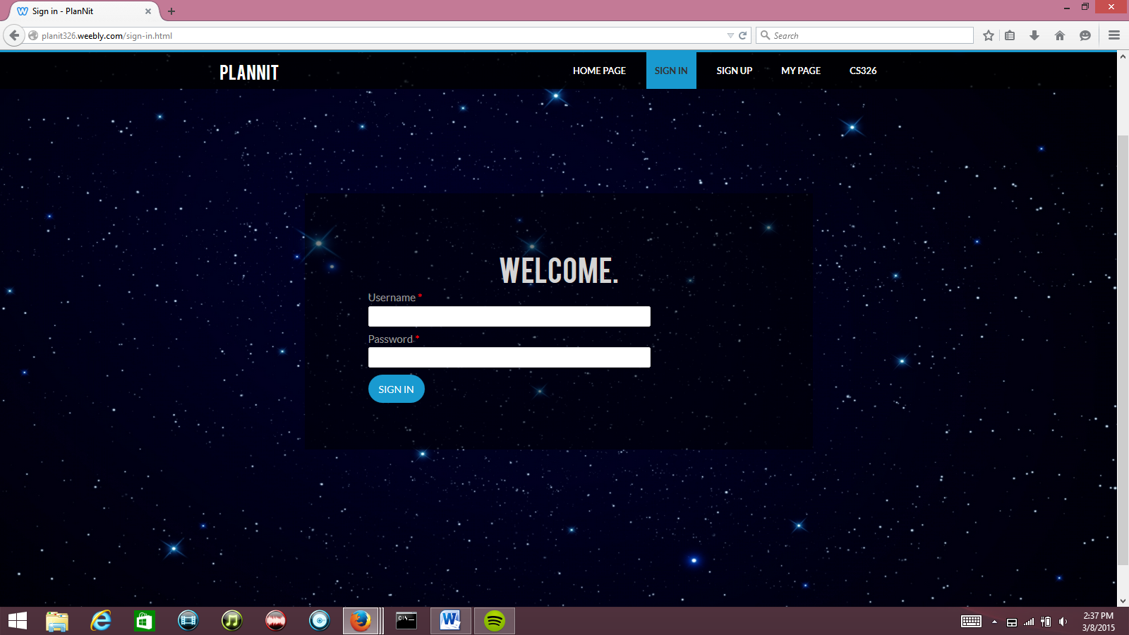**Registration Page:**For first time users, they can click on the sing up button, which will bring them to a registration page. Here the user will have to provide their name, username, password, and email to complete their registration.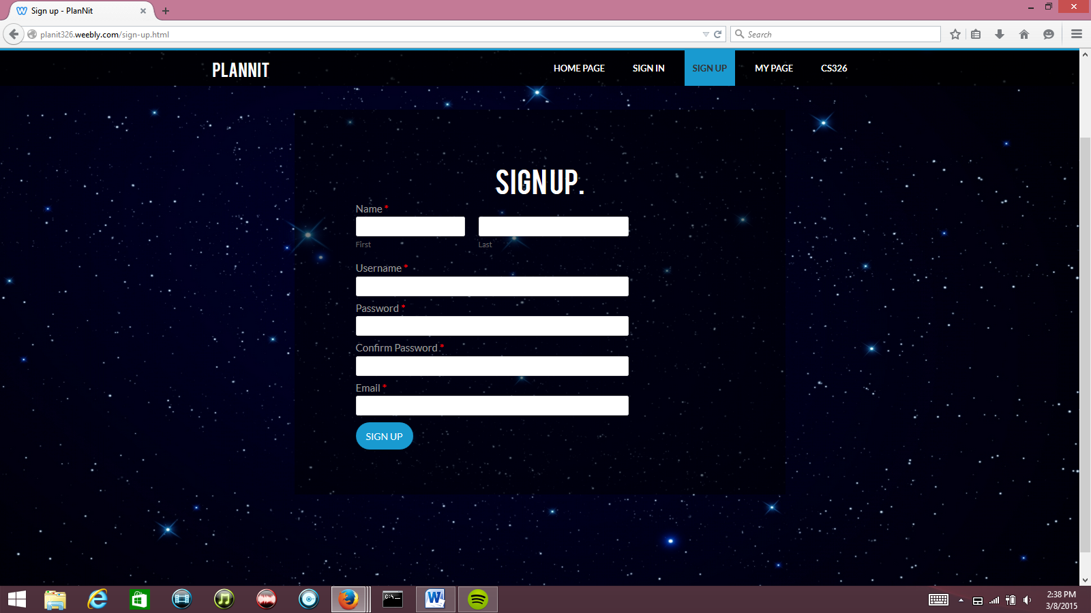 **“My Page”:**Once the user logs in, they will be brought to their “my page” (profile page). The profile page will consist of modules created by the user and an option at the bottom for adding more modules. The first default module will be a “to do list” that keeps track of upcoming events/assignment that are due. The other modules will serve as link that brings the user to each “class page”.

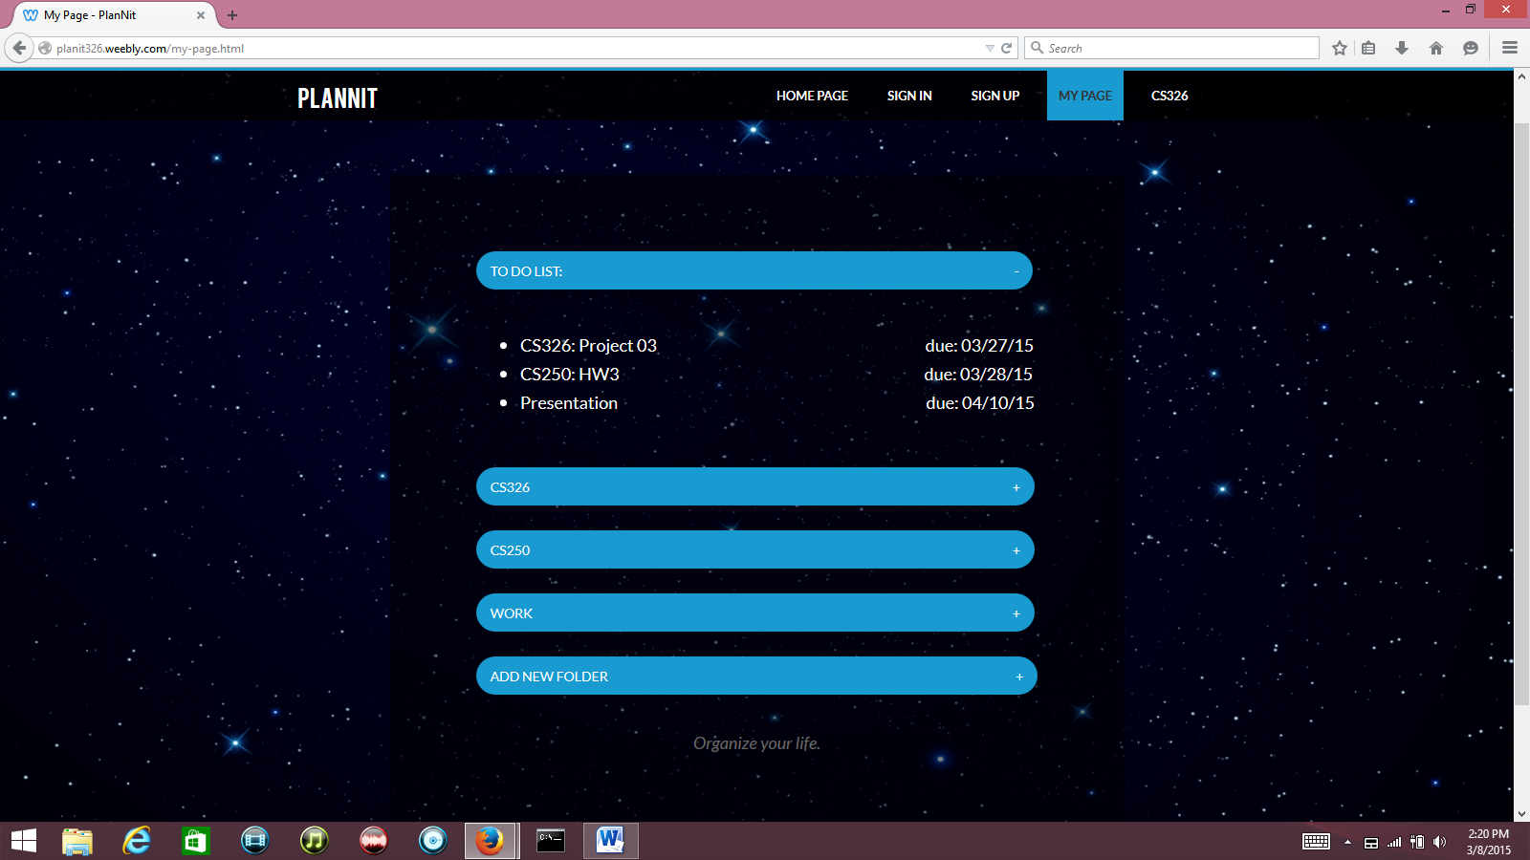

**Class Page:**This page will be blank to start with and will only consist of a title (in this case the title is the class name). The user will be able to add different modules and options depending on what the “Class Page”. The user takes full control of what they want each page to look like (lots of customization features). For example, the user can have an upcoming events section that keeps track of their due dates along with a calendar.

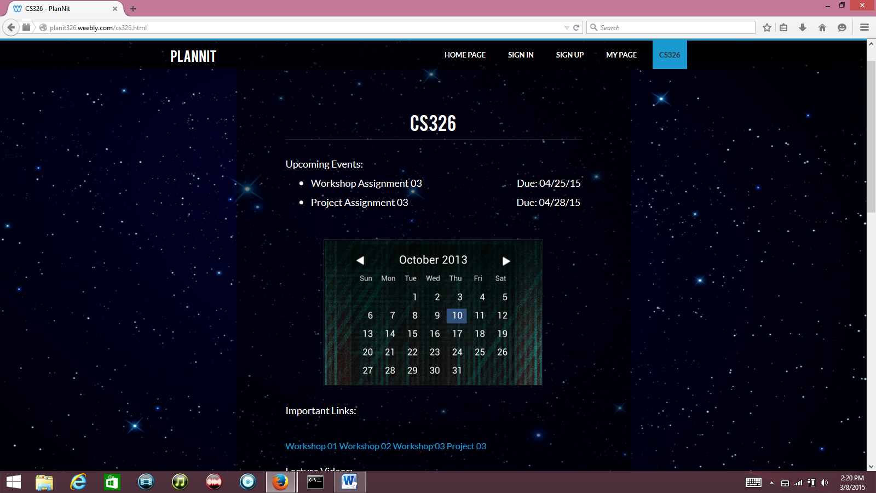

(**cont.)**Other options.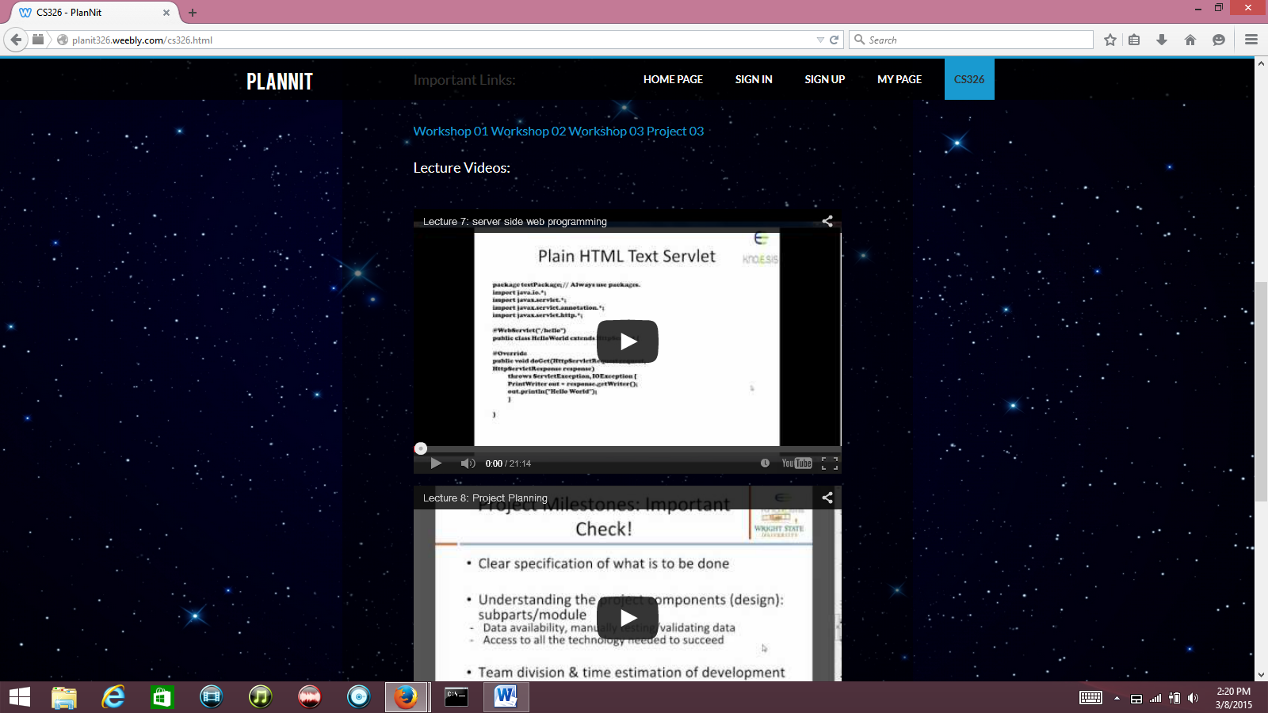

**(cont.)**